**CSS Combinators**

**CSS Combinators:**

The CSS combinators represent the relationship between two selectors.

The CSS selectors are the patterns that can be used for styling the particular HTML element. Sometimes, it is possible that there is more than one simple selector, and to combine the multiple simple selectors, we use the combinators.

# Why use CSS Combinator❓

Learning about combinators makes you **better at writing CSS** and **helps you to avoid excess CSS code.**

Combinators can also help you **pinpoint the section** or **part of HTML** you want to style with high accuracy because they are based on the **relationship between the selectors.**

# Types of Combinators in CSS

The combinators are of 4 types, which are given below:

1. Descendant Selector
2. Child Selector
3. General Sibling Selector
4. Adjacent / Immediate sibling Selector

# Descendant Selector in CSS

**Descendant Meaning:** A person who is related to you and who lives after you, such as your child or grandchild

Min 2 , can be greater than 2

Syntax

selector1 selector2 selector3... {

// style properties

}

**Practical example:**

<!

DOCTYPE html

>

<

html

>

<

head

>

<

style

>

div p {

/* It will select all p's which are descendants of div */

background-color: teal;

}

<

/style

>

<

/head

>

<

body

>

<

div

>

<p>Paragraph 1 in the div.</p>

<p>Paragraph 2 in the div.</p>

<span><p>Paragraph 3 in the div.</p></span>

<

/div

>

<

p>Paragraph 4. Not in a div, not a descendant</p

>

<

p>Paragraph 5. Not in a div, not a descendant</p

>

<

/body

>

<

/html

>

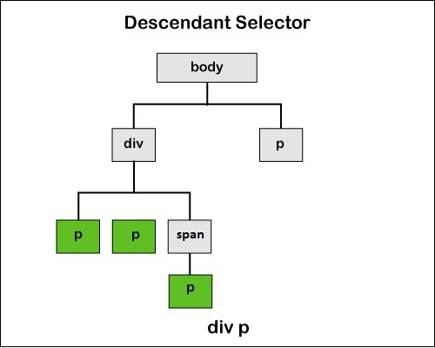

In the above figure div, p will select all p’s which are descendants of div

# Child Selector

The child selector uses the greater than sign (>) to separate the elements. The child selector is used when we want to apply the styling properties to the immediate child/children of the particular HTML element.

This combinator is quite strict than the descendant selector and the styling properties are acquired only when the second selector is the direct child of the first one.

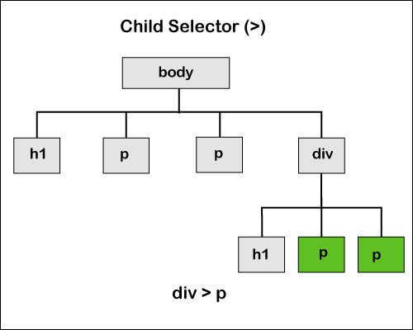

In the above figure

div>p

will select all p’s which are

childs

of div

**General Sibling Selector:**

**Sibling meaning:** A brother or sister from the same parent

The general sibling selector is used when the user wants to set the CSS properties for the elements that are the siblings of each other even if they are not the immediate ones.

This selector is used when we have to set the styling properties of the elements that have the same parent element. This selector can be separated by adding the (~) sign between them.

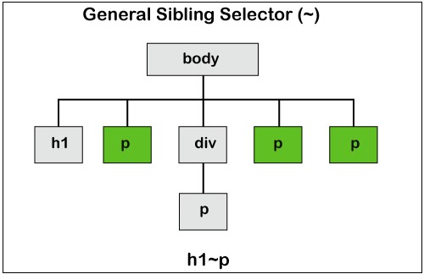

In the above figure

h1 ~ p

will select all p’s which are siblings of h1

# Adjacent / Immediate sibling Selector in CSS

The adjacent sibling selector is used when we want to apply the CSS property or styling to the adjacent sibling of any element.

The siblings should have the same parent element and also the second element must be the immediate follower of the first element.

The selectors are separated by adding the (+) sign between the separators.

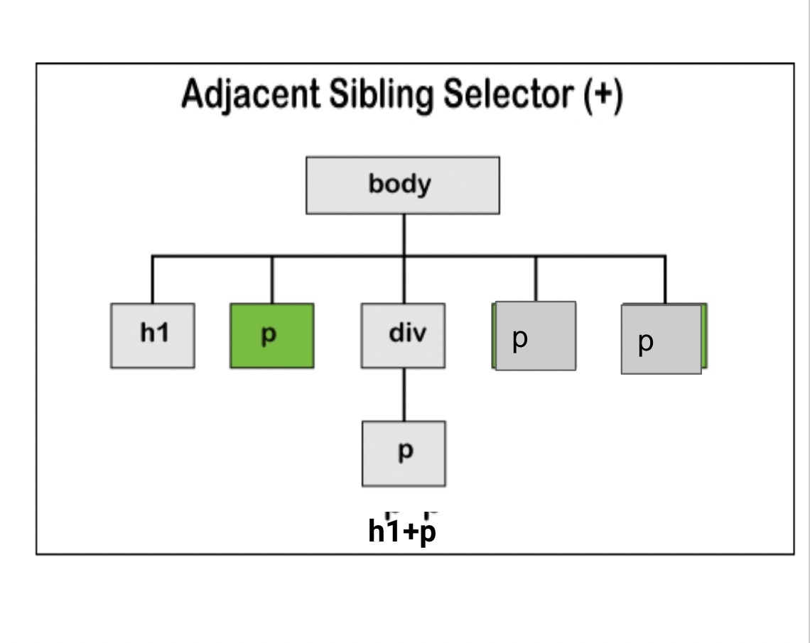

**Overview of all selectors:**



      
      
      
      
      
      
      